Ideation Phase

Brainstorm & Idea Prioritization Template

|  |  |
| --- | --- |
| Date | 03 NOV 2023 |
| Team ID | NM2023TMID04368 |
| Project Name | Data-Driven Insights on Olympic Sports Participation and Performance |
| Maximum Marks | 4 Marks |

Brainstorm & Idea Prioritization :

Step-1: Team Gathering, Collaboration and Select the Problem Statement

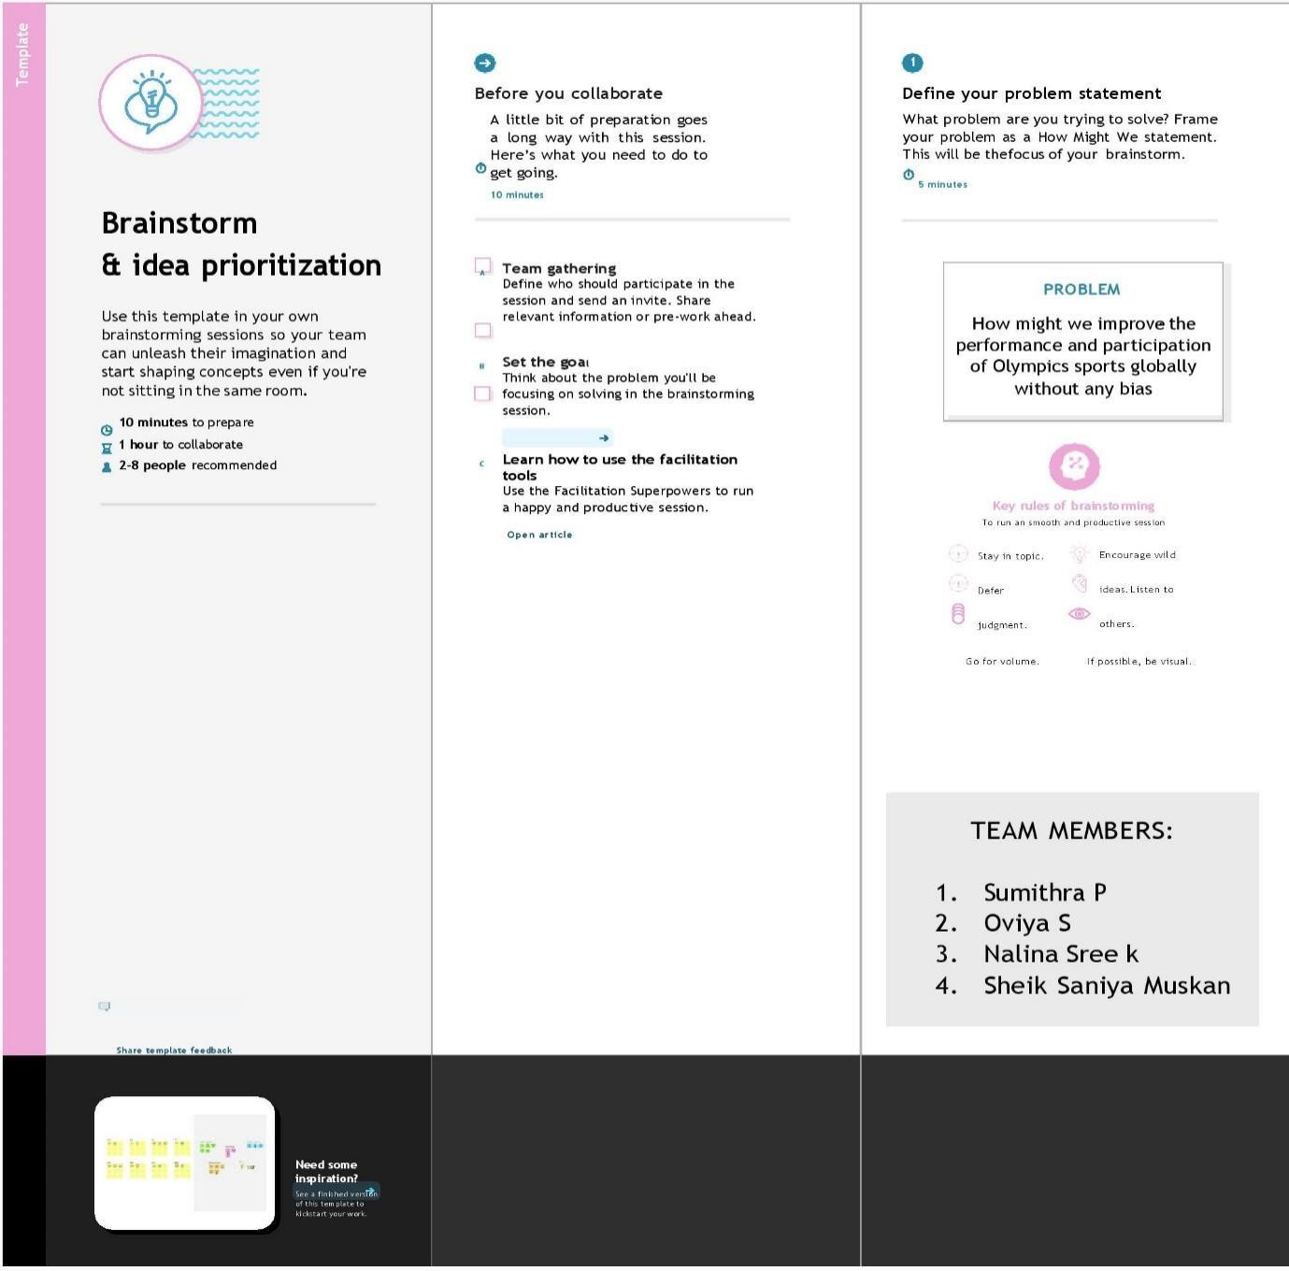

1. BALA S
2. KATHIRESAN S
3. SANTHOSH S
4. SURYA PRAKASH P

Step-2: Brainstorm, Idea Listing and Grouping

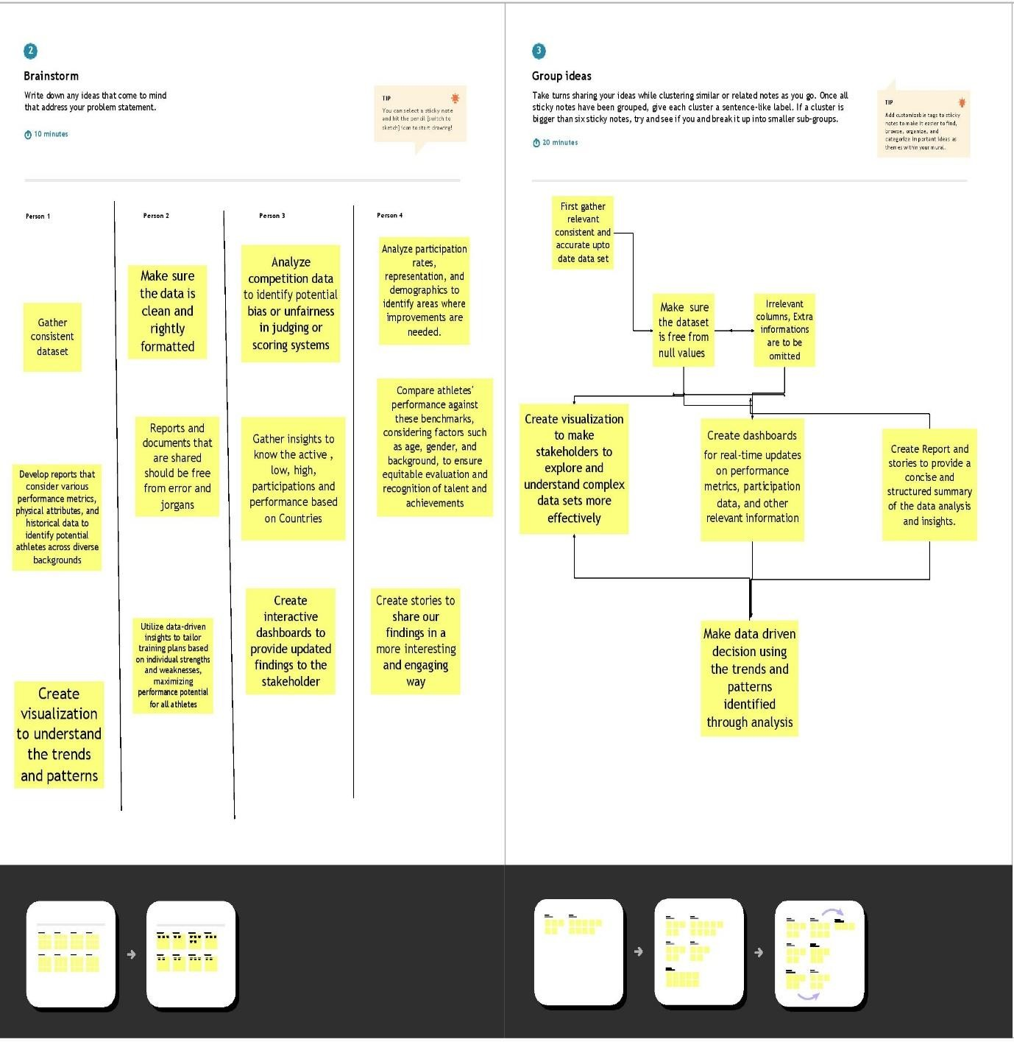

Step-3: Idea Prioritization

